Alexandria University,

Faculty of Engineering,

Computer and Systems Engineering Dept.

CS222: System programming

|  |
| --- |
|  |

Lab (2) Report

Name:

Abdel-Fatah Mohamed Abdel-Fatah. (24)

Content:

1. Simulator.
2. PROGRAMS.

1. Write a program that searches for a certain byte in a string, if found, put the address of the byte in register A else, put 0xFFFFF.
2. Read a string from an input device and print it reversed to an output device.
3. Read a string from an input device and print the string to an output device after converting it to UPPER case.
4. Implement the bubble sort to sort characters in a string.

***Simulator:

(before all examples).

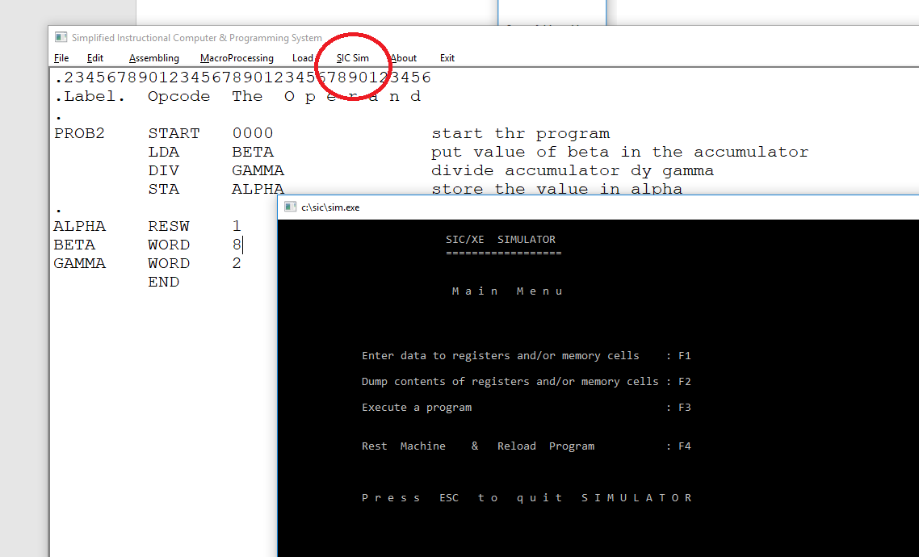

* 1. Execute a program (F3).

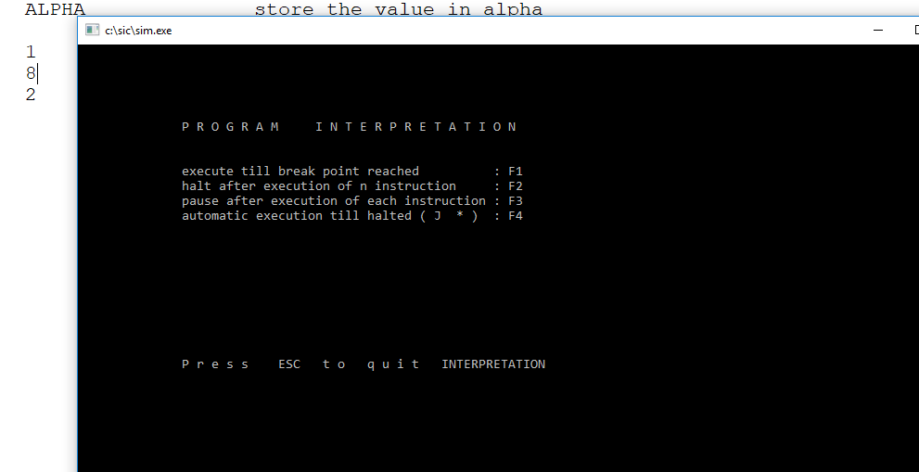

b. Automatic execution till halted (F4):

And press any button to execute instruction till the end.

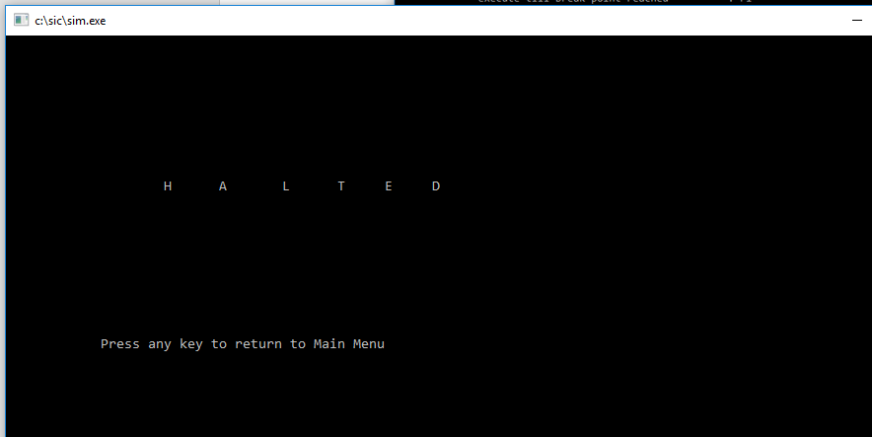

C. Dump contents of registers and/or memory cells (F2):

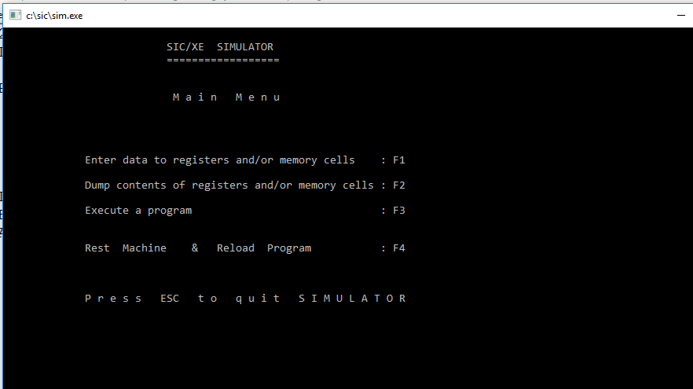

D. Contents of Reg. and Memory (F3):

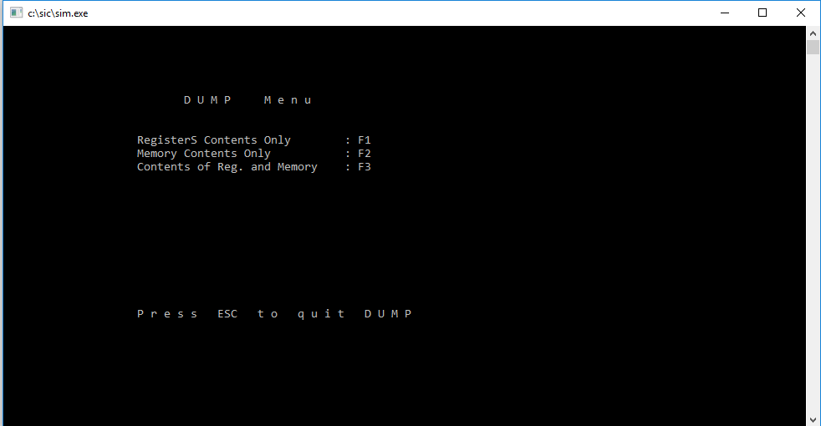

1. Write a program that searches for a certain byte in a string, if found, put the address of the byte in register A else, put 0xFFFFF:
2. Code:

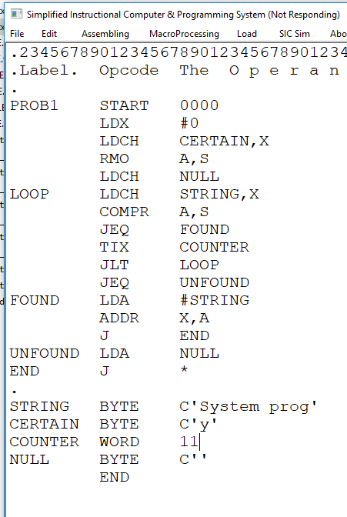

1. Assembling:

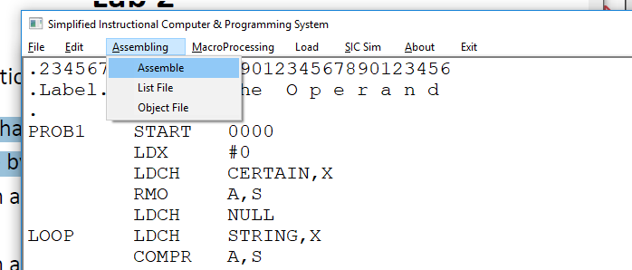

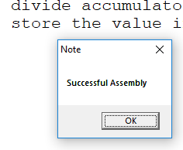

1. Sample run:

String = " System prog ", Certain = 'y',

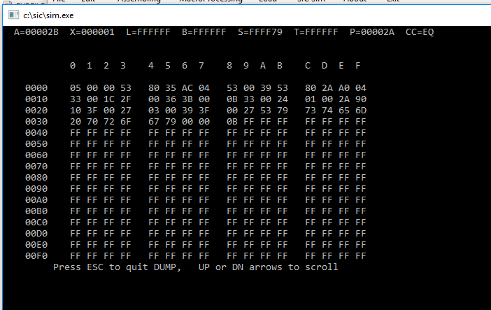

String = "System prog", Certain = 'Z',

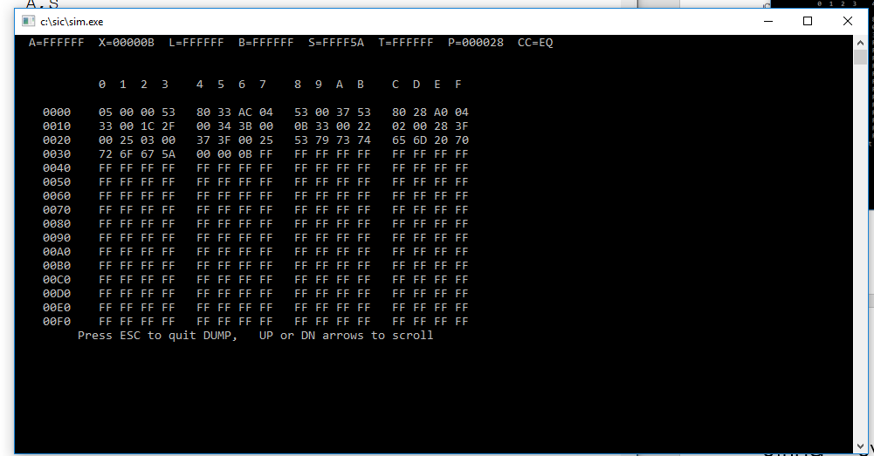

1. Read a string from an input device and print it reversed to an output device:
2. Code:

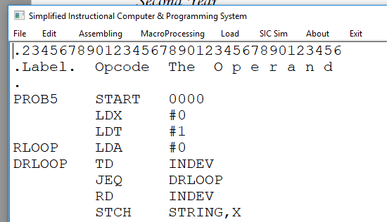

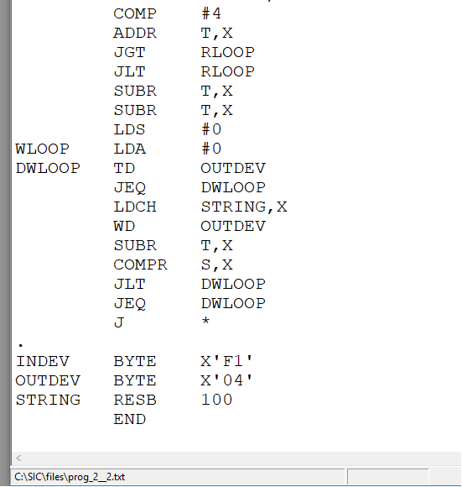

1. Assembling:

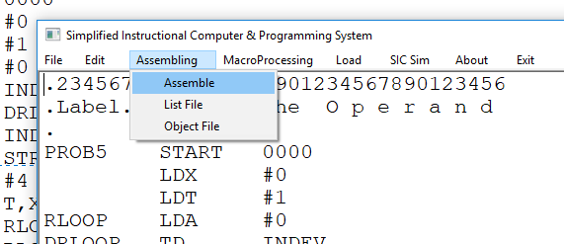



1. Sample run:

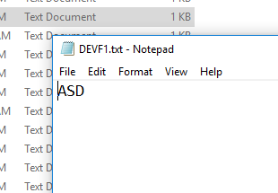 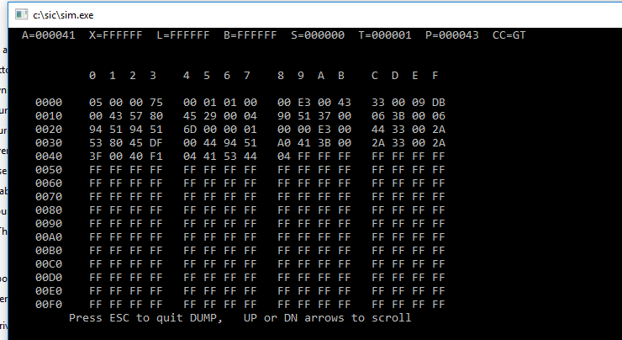

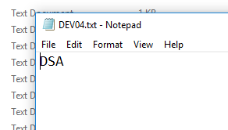

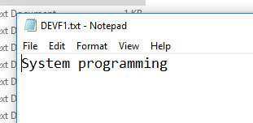

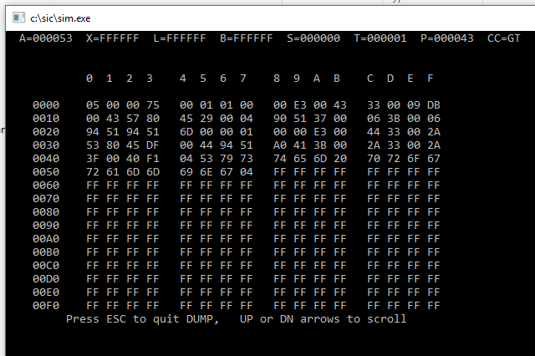

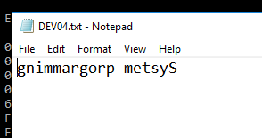

1. Read a string from an input device and print the string to an output device after converting it to UPPER case:
2. Code:

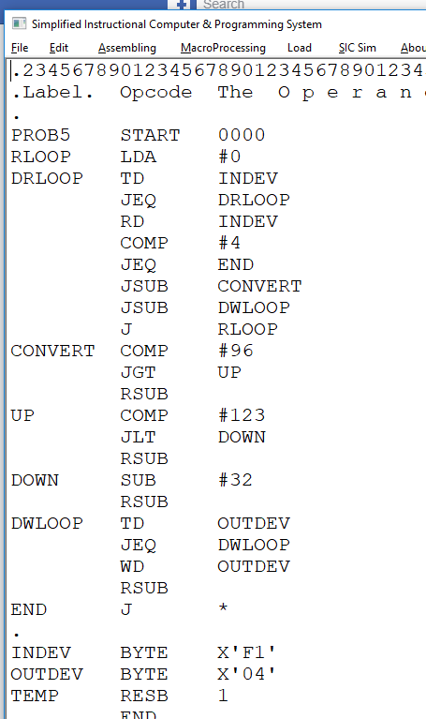

1. Assembling:

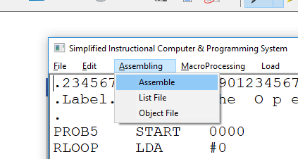



1. Sample run:

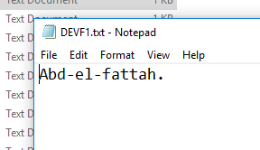

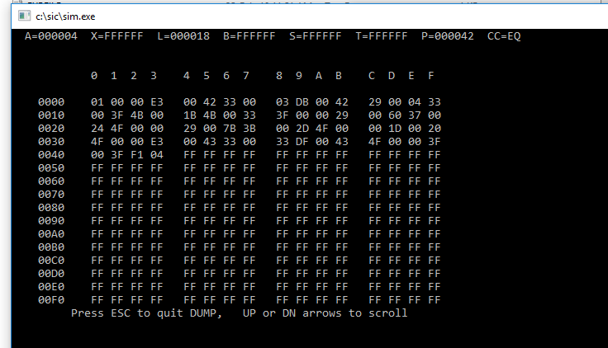

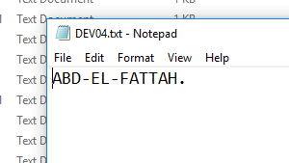

1. Implement the bubble sort to sort characters in a string:
2. Code:

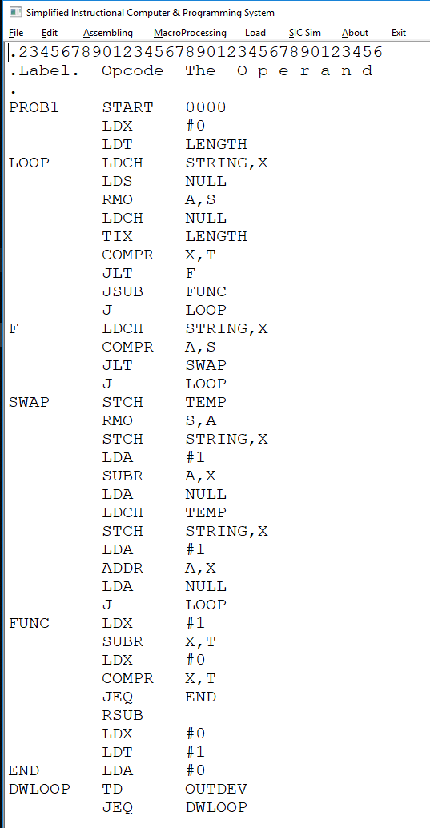

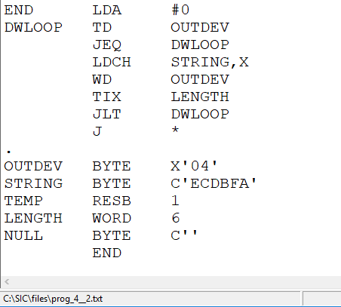

1. Assembling:

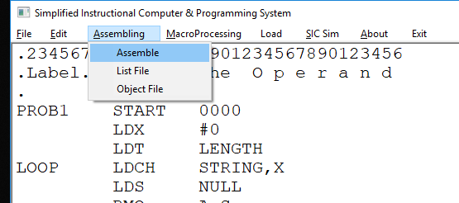



1. Sample run:

String = " ECDABF " output = "ABCDEF"

